 | EVERCARE  APPLICATION DEVELOPMENT

WEEK 4 ACTIVITY
CRUD Implementation
Journal Entries with Supabase persistence
STUDENT | Brent Lawrence C. Bernardo
SECTION | ITE231
PROFESSOR | Paul John Cabance
SUBMISSION DATE | August 12, 2026

Selected entity
Journal Entries
EverCare caregivers can create, read, update, bookmark, filter, and safely delete private diary entries. Records are stored in Supabase PostgreSQL, while optional photos use a private Supabase Storage bucket.
4 CRUD OPERATIONS | SUPABASE DATABASE | OWNER-ONLY RLS

Repository: github.com/Brentttttttt/evercare

IMPLEMENTATION SUMMARY
How CRUD works in EverCare
The existing Journal Entries feature is the project entity used for Week 4. It satisfies the activity without adding duplicate demo-only logic: the production Flutter screens call one repository, and that repository performs owner-scoped operations against Supabase.
CREATE  New entry | READ  List + reader | UPDATE  Edit entry | DELETE  Confirm + remove

CRUD evidence matrix
Operation | User interface | Repository method | Persistent result
Create | Add Journal Entry + notebook form | createEntry() | INSERT into journal_entries
Read | Journal cards + full diary reader | fetchEntries() | SELECT owner rows, newest first
Update | Prefilled Edit Journal Entry form | updateEntry() | UPDATE row and reconcile photos
Delete | Destructive confirmation dialog | deleteEntry() | DELETE row and stored photos

Validation and user protection
• Title and journal body are required and trimmed before saving.
• Custom tags are trimmed, limited to 30 characters, and checked for duplicates.
• The form prevents double submission and preserves writing after an error.
• Unsaved changes and permanent deletion both require confirmation.
• Photo attachments are limited to five and use clear loading/error states.
Persistence and privacy
Supabase PostgreSQL stores journal records. Row Level Security restricts each query and mutation to auth.uid(). The repository also filters by user_id. Optional photos use the private journal-photos bucket, owner-scoped paths, and time-limited signed URLs. No service-role credential is embedded in Flutter.

SCREENSHOT EVIDENCE 01
Create operation and data validation
The create flow uses the production notebook-style form. The first screenshot shows required-field validation. The next screenshots show a completed title and journal body ready to save.
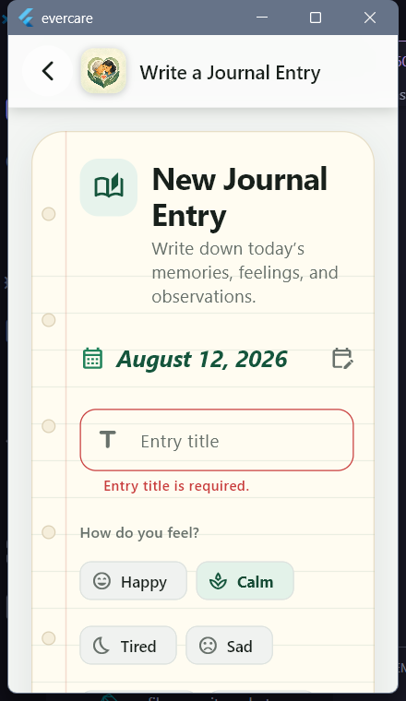  1. Required title validation | 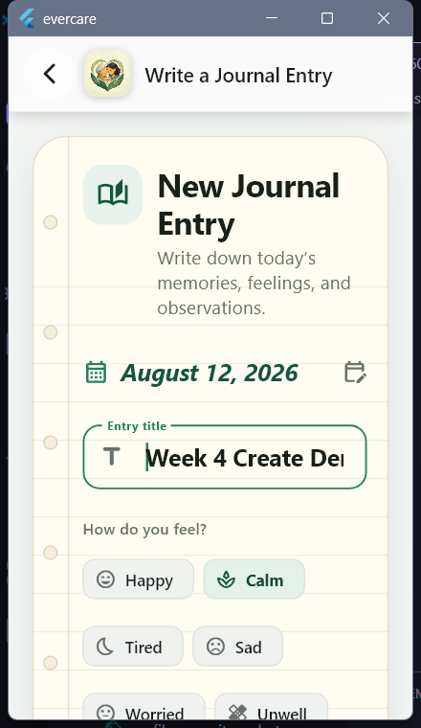  2. Create form with a valid title | 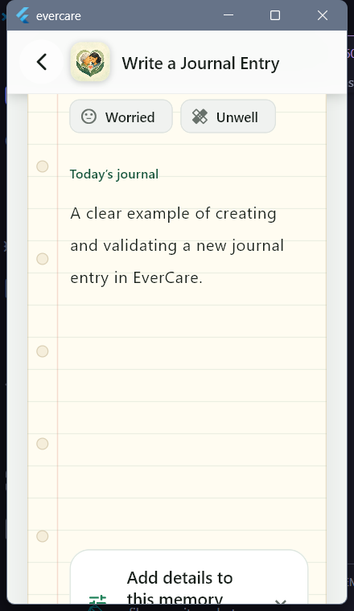  3. Journal body entered

Create result: createEntry() inserts an owner-scoped journal_entries row in Supabase.

SCREENSHOT EVIDENCE 02
Read and update operations
Saved entries are loaded from Supabase and displayed as journal cards. Selecting View opens the full diary reader. Editing restores the current values, then saves only the requested changes.
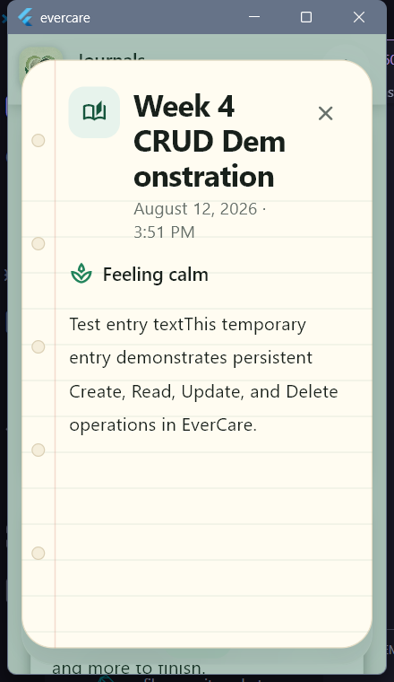  4. Read: full journal reader | 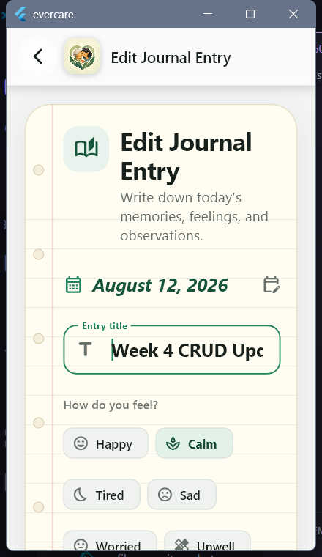  5. Update: prefilled edit form | 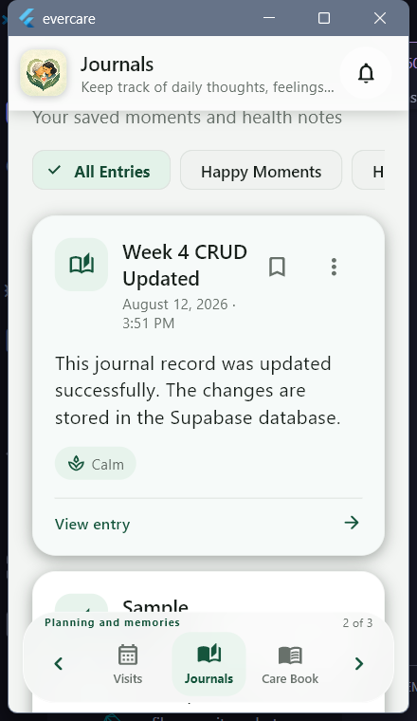  6. Updated record returned to the list

Update behavior
• Existing date, mood, title, body, symptoms, activities, tags, and photos are restored.
• The update query matches both the entry ID and the signed-in user ID.
• Unchanged photos are preserved; newly added and removed photos are reconciled.
• The list refreshes after a successful update, confirming the new persisted values.

SCREENSHOT EVIDENCE 03
Safe delete operation
Delete is intentionally destructive and requires explicit confirmation. The dialog explains that the journal entry and its attached photos will be permanently removed.
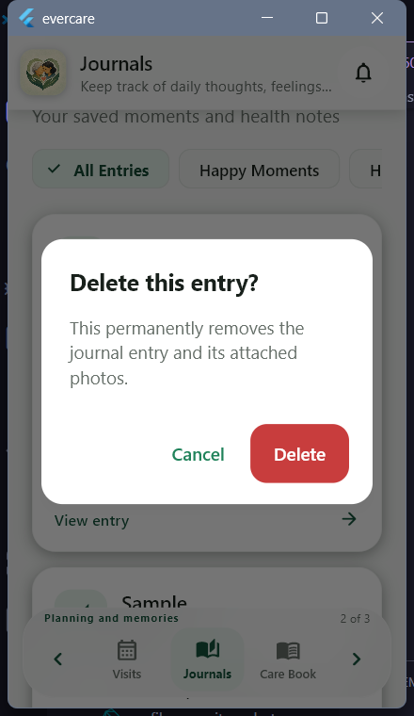  7. Permanent-delete confirmation | 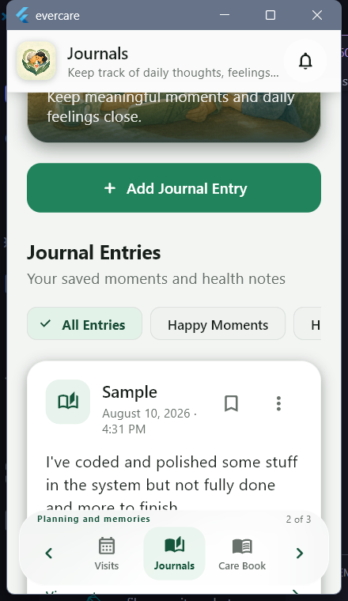  8. List refreshed after deletion

Deletion result
The temporary classroom record was removed after these screenshots were captured. JournalRepository.deleteEntry() first removes any owner-scoped Storage objects, then deletes the matching journal_entries row. Photo metadata is protected by owner RLS and cascades from the entry foreign key.
PRIVACY NOTE • Screenshots use non-sensitive classroom demonstration text. No patient health information was created for this submission.

VERIFICATION AND HANDOFF
Testing results
Check | Result | Evidence
Windows debug build | PASSED | Current source built successfully
flutter analyze | PASSED | No issues found
flutter test | PASSED | 99 tests passed

Key implementation files
File | Responsibility
lib/repositories/journal_repository.dart | Supabase CRUD, photos, signed URLs
lib/screens/journals/journals_screen.dart | List, filters, actions, delete confirmation
lib/screens/journals/journal_entry_form.dart | Create/edit UI and validation
supabase/migrations/*.sql | Tables, constraints, private Storage, RLS

How to reproduce the CRUD workflow
1. Sign in to EverCare and open Journals.
2. Tap Add Journal Entry, complete the required title and body, then save.
3. Tap the card to read it; use the three-dot menu to edit or delete.
4. Confirm deletion and verify that the list refreshes without the record.
Submission checklist
• Updated Flutter project source code — included as EverCare_Week4_Source_Code.zip.
• Create, Read, Update, Delete, and validation screenshots — included in screenshots/.
• Brief CRUD documentation — this DOCX and matching PDF.
• Persistent Supabase database, owner-scoped RLS, and user-friendly confirmation flows.
GitHub repository
https://github.com/Brentttttttt/evercare

